SLEEP HEALTH ANALYSIS
A project developed in
partial fulfilment
of AISCEE (XII) 2024-25
in
INFORMATICS PRACTICES
Submitted by:
Ativeer Godha(12-B)
Jahanvi Sharma(12-F)
Under the guidance of:
Smt. Kalpana Gupta
(Head, I.T Dept.)
B.V.B Vidyashram, K.M. Munshi Marg, Jaipur
CONTENTS

1. ACKNOWLEDGEMENT
2. CERTIFICATE
3. INTRODUCTION
4. SYSTEM REQUIREMENTS
5. DATA DICTIONARY
6. SOURCE CODE
7. OUTPUT
8. CONCLUSION
9. FUTURE ENHANCEMENTS
10. BIBLIOGRAPHY

ACKNOWLEDGMENT
I undertook this Project work, as the part of my XII-Informatics Practices course. I had tried to apply my best of knowledge and experience, gained during the study and class work experience However, developing software system is generally a quite complex and time-consuming process. It requires a systematic study, insight vision and professional approach during the design and development Moreover, the developer always feels the need, the help and good wishes of the people near you, who have considerable experience and idea
I would like to extend my sincere thanks and gratitude to my teacher Smt. Kalpana Gupta.
I would like to take the opportunity to extend my sincere thanks and gratitude to my parents for being a source of inspiration and providing time and freedom to develop this software project.
I also feel indebted to my friends for the valuable suggestions during the project work.

ATIVEER GODHA (XII- B)
JAHANVI SHARMA (XII-F)

CERTIFICATE

This is to certify that the Project / Dissertation entitled Sleep Health Analysis is a bonafide work done by Ativeer Godha of class XII-B and Jahanvi Sharma of class XII-F Session 2024-25 in partial fulfillment of CBSE's AISSCE Examination 2025 and has been carried out under my direct supervision and guidance. This report or a similar report on the topic has not been submitted for any other examination and does not form a part of any other course undergone by the candidate.

Kalpana Gupta
(Head, IT Dept.)

INTRODUCTION
This Python code utilizes the pandas and matplotlib libraries to conduct a comprehensive analysis of sleep health and lifestyle variables. It introduces a user-friendly menu system for easy exploration of diverse insights. The analysis includes compelling visualizations like pie charts highlighting occupation groups affected by sleep deprivation, line charts visualizing age groups experiencing good sleep quality, and bar charts presenting the most active occupation and age groups. Additionally, there are informative stacked bar charts showcasing the correlation between sleep disorders and BMI categories, histograms capturing age distribution, and dual-line graphs contrasting stress and physical activity levels across different ages. The script further identifies the prevailing sleep disorder and compares physical activity to daily steps through histograms, as well as BMI categories against physical activity levels using stacked bar charts. Collectively, these visualizations provide a comprehensive understanding of sleep patterns and lifestyle influences within the dataset, making it an engaging and informative project.

SYSTEM REQUIREMENTS

- HARDWARE:
- Pentium dual core processor or higher
- 2 GB Ram or higher
- SVGA & other required devices

- SOFTWARE:
- Microsoft windows XP/7/8/10
- Python IDLE Version 3 or above (Front end requirement)
- MySQL (Back end requirement)
- Microsoft word version 2007 and above for documentation
- Microsoft excel version 2007 and above for data storage (CSV)

DATA DICTIONARY
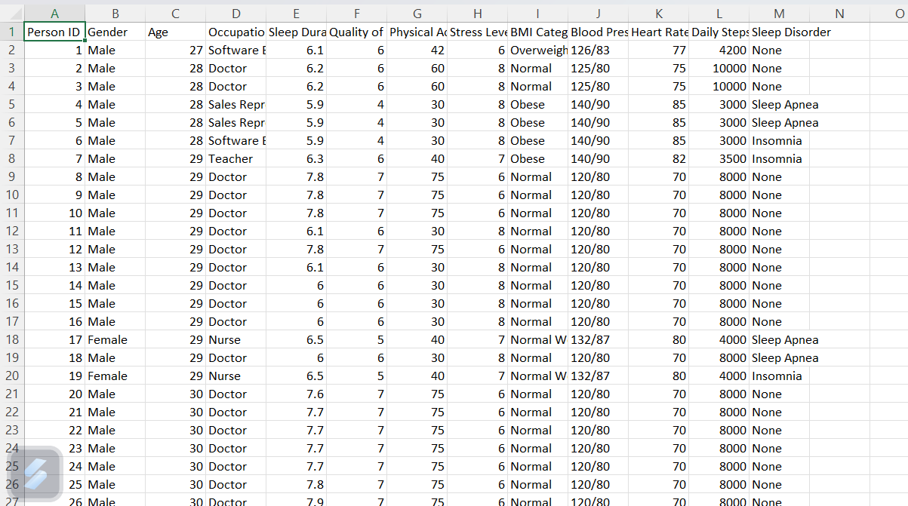
COLUMNS OF CSV FILE
- PERSON ID
- GENDER
- AGE
- OCCUPATION
- SLEEP DURATION
- QUALITY OF SLEEP
- PHYSICAL ACTIVITY LEVEL
- STRESS LEVEL
- BMI CATEGORY
- BLOOD PRESSURE
- HEART RATE
- DAILY STEPS
- SLEEP DISORDER
- S.no. | Python function | Purpose
1 | introduction() | code for introduction
2 | made_by() | code for credits
3 | read_csv_file() | code to read csv file
4 | main_menu() | code for main menu of project
5 | data_analysis_menu() | code for data analysis
6 | graph() | code for graphs
7 | export_menu() | code for export function
8 | clear() | code for clearing screen

SOURCE CODE
import pandas as pd
import matplotlib.pyplot as plt
df=pd.read_csv(r"D:\IP 2024-25\ATIVEER & JAHANVI\\ip project csv.csv")
df
a=input("Enter your name")
print('Hey.',a,'Sleep health is crucial for maintaining both physical and mental well-being. It is during sleep that the body repairs itself, processes memories, and restores energy levels. Adults typically need 7-9 hours of sleep each night to function optimally, but quality is just as important as quantity. Poor sleep can lead to various issues, such as fatigue, irritability, and a weakened immune system. Chronic sleep deprivation is linked to health problems like heart disease, diabetes, and depression. ')
while True:
print (".........................................MAIN MENU.............................................")
print("1. To display the sleep distribution with different heart rates")
print("2. To display the distribution of sleep in different age groups")
print("3. To display the sleep duration vs physical activity")
print("4. To display the relation between sleep quality and age groups")
print("5. To display csv file")
print("6. Exit ")

ch=int(input("Enter your choice"))
if ch==1:
print("THANK YOU" , a)
df.plot(kind='hist',x='Sleep Duration',y='Heart Rate',color='green')
plt.title('sleep distribution with different heart rates')
plt.show()
elif ch==2:
print("THANK YOU" , a)
df.plot(kind="line", x='Age',y='Sleep Duration',color='blue')
plt.title("distribution of sleep in different age groups")
plt.show()
elif ch==3:
print("THANK YOU",a)
df.plot(kind='bar',x='Quality of Sleep',y='Physical Activity Level',color='red')
plt.title("sleep duration vs physical activity")
plt.show()
elif ch==4:
print("THANK YOU",a)
size=df.Age*5
df.plot(kind='scatter',x='Quality of Sleep',y='Age', s=size, color= 'green', marker='*')
plt.title(" sleep quality vs age")
plt.show()
elif ch==5:
print(“THANK YOU”, a ,df)
elif ch==6:
print("Thank you for being with us and taking the time to review our analysis. We hope that the insights provided have been valuable and informative.")
brea
OUTPUT
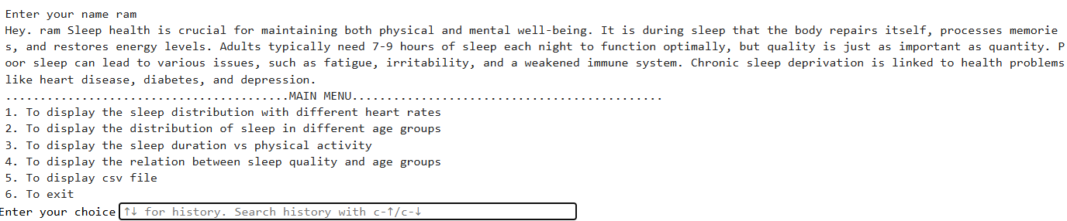
On selecting choice1:-
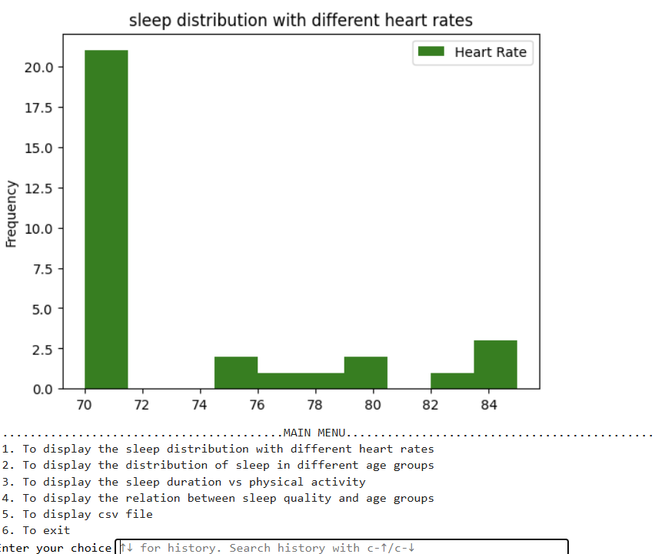
On selecting choice 2:-
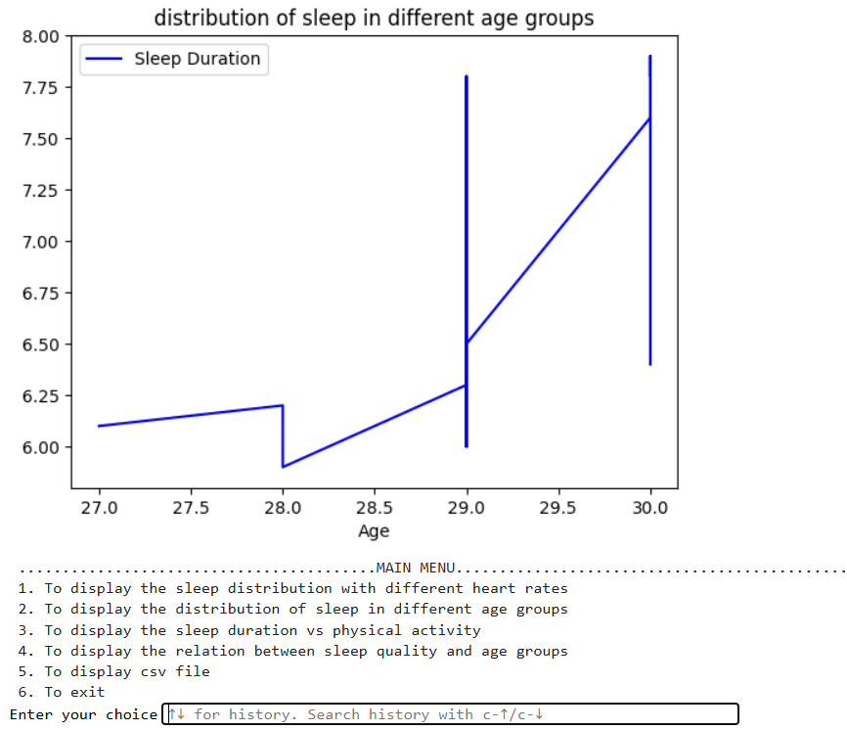
On selecting choice 3:-
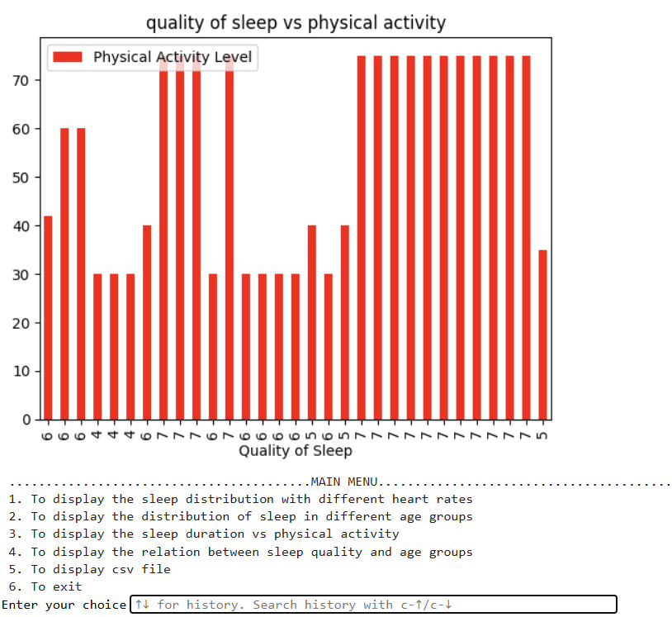
On selecting choice 4:-
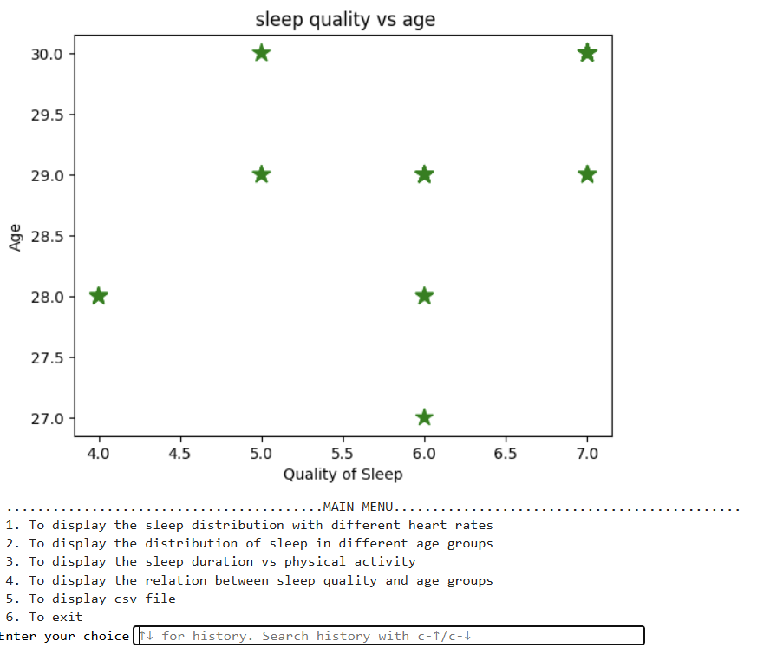
On selecting choice 5:-
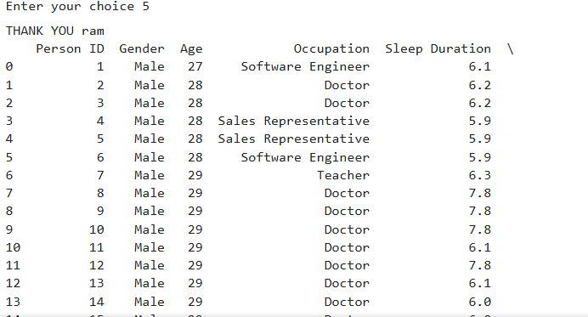

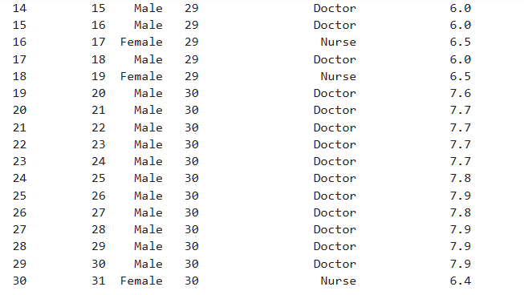
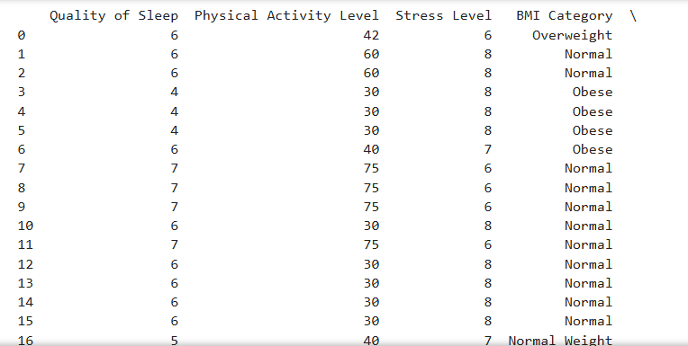

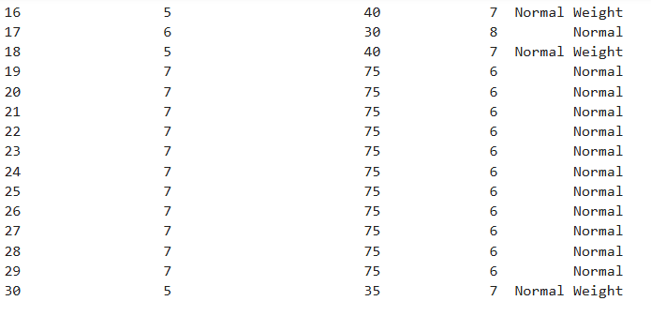
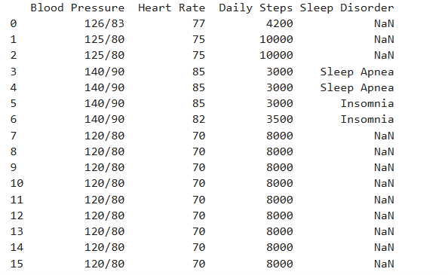

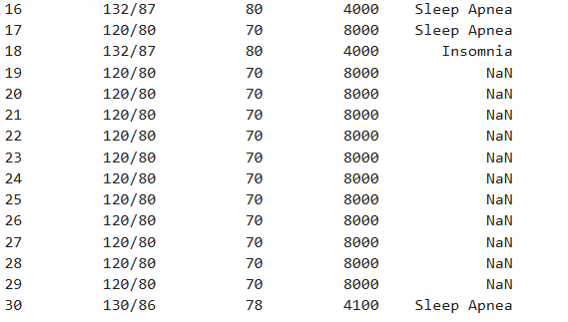
On selecting choice6:-

CSV FILE

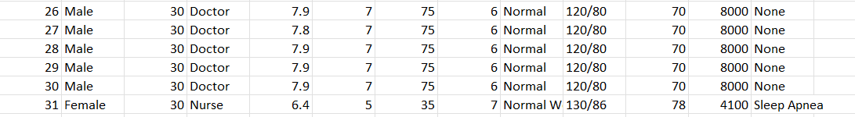

CONCLUSION
This software is fully functional and can be used as is, but with future improvements, it has the potential to be even more accessible and versatile.
The system allows students to study coding and programming from the comfort of their homes, offering a convenient learning experience. Projects like these make studying more engaging and enjoyable, helping students grasp complex concepts while enhancing their skills and knowledge.

FUTURE ENHANCEMENTS
In the future, we plan to add more modules to this project. The proposed system will offer users a choice of data screens that closely resemble the formats of the source documents. To reduce data entry errors, validity checks will be implemented, ensuring that only verified data is stored in the permanent database. Additionally, we aim to integrate database connectivity with Python Pandas, making the data more accessible for sharing and easier to manipulate.

BIBLIOGRAPHY

- BOOKS:-
- Informatics Practices NCERT book class XI & XII published by NCERT.
- Informatics Practices by Sumita Arora for class XI & XII published by Dhanpat Rai and Co.
- Informatics Practices by Preeti Arora for class XI & XII published by Sultan Chand.

- ONLINE REFERENCES:-
1. https://www.kaggle.com/
2. https://www.pythonforall.com/

